Corbridge Film Nights 2019 -2020

Lucky – 15 September 2019
2017, USA, 88mins Dir. John Carroll Lynch

Lucky is an old US Navy veteran of rigid habits and attitudes in a small town. When his routine is suddenly interrupted by a collapse at home, he has to accept that his remarkably healthy old age is going to face inevitable decline. In doing so, Lucky finds that his life has its positive side as he searches for some meaning.
Shoplifters – Sunday 6 October 2019
2018, Japan, 121mins Dir. Hirokazu Kore-eda

Set in contemporary Japan but with a storyline that could be straight out of Dickens. It combines tear- jerking sentimentality with hard-hitting social comment. Kore-eda’s characters engage in petty crime but do so to survive. Through all their hardships, Osamu and his wife and son are a happy family unit. When they take in a little girl their life takes a different turn…Despite the challenging topics, the tone of the film is surprisingly upbeat.
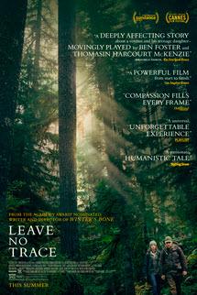 | Leave no Trace – Sunday 27 October 2019  2018, USA, 109mins Dir. Debra Granik  Will and his teenage daughter, Tom have lived off the grid for years in the forests of Portland, Oregon. When their idyllic life is shattered, both are put into social services. After clashing with their new surroundings, Will and Tom set off on a harrowing journey back to their wild homeland.
The White Crow – Sunday 24 November 2019
2018, UK, 127mins Dir. Ralph Fiennes

The true story of Rudolf Nureyev whose escape to the West stunned the world at the height of the Cold War. Nureyev was a wild and beautiful dancer limited by the world of 1950’s Leningrad. His flirtation with Western artists and ideas led him into a high-stakes game of cat and mouse with the KGB.

Our Christmas Film – Sunday 15 December 2019

To celebrate Christmas and our 10th anniversary this film is free. For various reasons this is a surprise. What we can say is that it’s a recent foreign comedy that fits in with the time of year. Oh, and it is free.
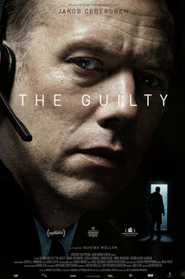 | The Guilty – Sunday 12 January 2020  2018, Denmark, 85mins Dir. Gustav Moller  Alarm dispatcher and former police officer Asger Holm answers an emergency call from a kidnapped woman. When the call is suddenly disconnected, the search for the woman and her kidnapper begin. The film takes place in two rooms; the story unfolds in a series of phone calls, and the result is a masterclass in wringing breathless tension from just a few key ingredients.
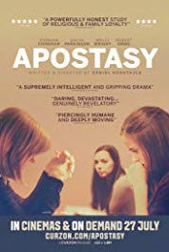 | Apostasy – Sunday 9 February 2020  2017, UK, 95mins Dir. Daniel Kokotajlo  As devout Jehovah’s Witnesses, Alex, her sister Luisa and their mother Ivanna, are united in “The Truth”. However, when Luisa begins to question the advice of the Elders, she is threatened with expulsion from the congregation. Unless Alex and Ivanna can persuade her to return, they must shun her completely. This challenge becomes more painful when their family is faced with another heartbreaking test of faith.
Foxtrot – Sunday 1 March 2019
2017, Israel, 113mins Dir. Samuel Maoz

A troubled family must face the facts when something goes terribly wrong at their son's desolate military post. A movie about fate, life, death, war, youth, love and dancing. Flawless beauty, amazing direction, vivid cinematography and incredibly intense acting in a fabulous 3-act tragedy

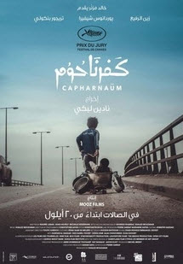 | Capernaum – Sunday 22 March 2019  2018, Lebanese, 126 mins Dir. Nadine Labaki  An heart wrenching, powerful, beautiful story of a handful of hapless, unlucky individuals navigating a cruel world. This “must see” film tells the story of Zain, a Lebanese boy, who sues his parents for the "crime" of giving him life. It received a 15 minute standing ovation at Cannes.
Woman at War – Sunday 19 April 2020
2018, Iceland, 101mins Dir Benedikt Erlingsson

Halla, a determined environmental activist, declares war on the local aluminium industry to prevent it from disfiguring her country. She risks all she has to protect the highlands of Iceland-but the situation could change with the unexpected arrival of a small orphan in her life. This offbeat comedy drama was Iceland’s entry to the Academy & Golden Globe Awards.

The season of 10 films costs only £35. You can also just pay on the door (£5)

For more information contact:
John Wills. email: johnwills118@btinternet.com, tel: 01434 633995

