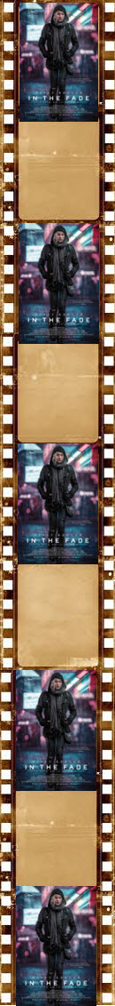

**Corbridge Film Nights**

Corbridge Parish Hall

Sunday 7 October

*“In The Fade”*

Film starts 7:30pm

(Doors Open 7:00pm)

£5 on door

***The threat of terrorism from the far right shapes this riveting and highly topical revenge drama. Katja’s world is shattered when her Turkish husband and son are killed in a bomb attack suspected to have been carried out by neo-Nazis. A tense, gripping courtroom drama ensues as the authorities attempt to bring the perpetrators to justice.***

***2017, Germany, 106mins Dir. Fatih Akim***

**Next Film: Like Father Like Son. Sunday 28 October**