Corbridge Film Nights 2018 -2019
Now in its ninth season, Corbridge Film Nights opens on Sunday 23 Sept with the film ‘Death of Stalin’. A Welcome Evening is planned for this first meeting with pre-film complimentary drinks and nibbles.

- Diverse, critically-acclaimed films from all over the world.
- Corbridge Parish Hall, Sunday evenings.
- Doors open 7.00pm. Film starts 7.30pm. Finish ~ 9:30pm.
- Free tea, coffee and biscuits.
- You are welcome to bring your own refreshments.

The season of 9 films costs only £35 or pay on the door (£5)
Contact : John Wills (filmnights@hotmail.com)

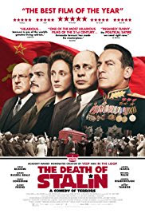 | The Death Of Stalin – 23 September 2018  2018, UK, 107mins Dir. Armando Iannucci  This black comedy depicts the chaos after Stalin’s death as the regime scramble to maintain order, weed out competition and ultimately, take power. In the incessant plotting, tireless machinations, and frail allegiances, absolutely no one is safe. But who will prevail? This very funny “comedy of terrors” received two bafta nominations.
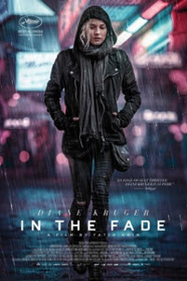 | In The Fade – Sunday 7 October 2018  2017, Germany, 106mins Dir. Fatih Akim  The threat of terrorism from the far right shapes this riveting and highly topical revenge drama. Katja’s world is shattered when her Turkish husband and son are killed in a bomb attack suspected to have been carried out by neo-Nazis. A tense, gripping courtroom drama ensues as the authorities attempt to bring the perpetrators to justice.
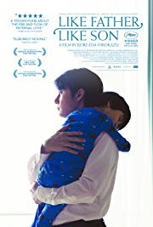 | Like Father Like Son – Sunday 28 October 2018  2013, Japan, 121mins Dir. Hirokazu Koreeda  Ryota is a successful Tokyo architect who works long hours to provide for his wife, Midori and 6 year-old son, Keita. When a blood test reveals Keita and another baby were switched at birth, two very different families are thrown together and forced to make a difficult decision.
A Fantastic Woman – Sunday 25 November 2018
2017, Chile, 104mins Dir. Sebastian Lelio

Marina, a young transgender woman is in a happy relationship with an older man. His sudden death is treated with suspicion by her lover’s family and she is even forbidden from attending his funeral. Marina’s struggle for acceptance in the face of prejudice is at the heart of this powerful film.
Joyeux Noel – Sunday 16 December 2018
2005, France, 116mins Dir. Christian Carion

Christmas Eve 1914 in the French, Scottish and German trenches are the setting for this true, momentous event where, after months of carnage, soldiers from both sides call an informal truce and meet each other in No-Man’s Land to exchange cigarettes, chocolate and a fleeting brotherhood.
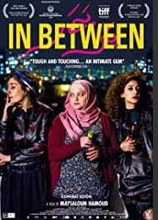 | In Between – Sunday 20 January 2019  2017, Israel, 103mins Dir. Maysaloun Hamoud  Three Palestinian woman living independently in the centre of Tel Aviv, away from their families and the weight of tradition, struggle to be true to themselves when confronting the expectations of others.
Sweet Country – Sunday 24 February 2019
2017, Australia, 113mins Dir. Warwick Thornton

Sam, a middle-aged Aboriginal man, is sent to help the ill-tempered Harry renovate his cattle yards. But when Sam kills Harry in self-defence he becomes a wanted man and is forced to flee across the deadly outback. While a hunting party is formed to track Sam down, as the true details of the killing start to surface, the community begins to question whether justice will really be served.
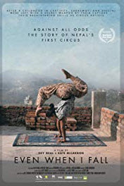 | Even When I Fall – Sunday 24 March 2019  2017, Nepal, 93mins Dir. Kate McLarnon/Sky Neal  Sheetal and Saraswoti are survivors of child trafficking to corrupt Indian circuses. This documentary film traces their journey over 6 years as they confront the families that sold them, seek acceptance within their own country and begin to build a future. As they struggle to survive they use the secret weapon they were given by their captors - their breath-taking skills as circus artists.
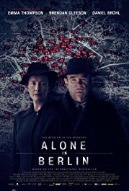 | Alone In Berlin – Sunday 14 April 2019  2016, Ger/Fran/UK, 103mins Dir Vincent Perez  A true-life tale of courage set against the tumultuous backdrop of Berlin in 1940. Otto and Anna Quangel are a working-class couple doing their best to ride out the war. However, when their son is killed at the front everything changes. They begin pouring their rage and grief into postcards emblazoned with anti-Nazi slogans, risking everything to disseminate their messages of protest across the city. But this seemingly small act of subversion rattles the Nazi regime, including a police inspector who will not rest until the culprits have been caught.

