Corbridge Film Nights 2017 -2018
Now in its eighth season, Corbridge Film Nights opens on Sunday 10 Sept with the film ‘Hidden Figures’. A Welcome Evening is planned for this first meeting with pre-film complimentary drinks and nibbles.

- Diverse, critically-acclaimed films from all over the world.
- Corbridge Parish Hall, Sunday evenings.
- Doors open 7.00pm. Film starts 7.30pm. Finish ~ 9:30pm.
- You are welcome to bring your own refreshments.

The season of 9 films costs only £35 or pay on the door (£5)

For an application form contact :

John Wills, email: johnwills118@btinternet.com, tel: 01434 633995
Tom Southren, email: tom.southren@btinternet.com,tel: 01434 634909

Hidden Figures – 10 September 2017
2016, USA, 127mins Dir. Theodore Melfi

In the early 1960's 3 black women mathematicians played a vital role in getting man into space. This little known true story provides a timely and uplifting account of 2 subjects which continue to destabilise and gnaw away at the soul of the USA -colour and gender.

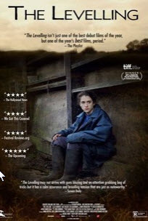 | The Levelling – Sunday 1 October 2017  2016, UK, 83mins Dir. Hope Dickson Leach  Following the 2014 floods on the Somerset levels the professional daughter of her farmer Dad answers his call to help with a family crisis. First time writer/ director tells a story where truths come out and pasts are confronted in this atmospheric, dark drama of rural family life you will not see in Escape to the Country.
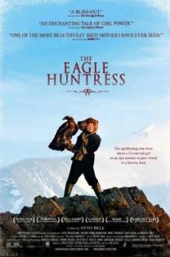 | The Eagle Huntress – Sunday 29 October 2017  2016, Mongolia, 87mins Dir. Otto Bell  This spellbinding documentary follows Aisholpan, a 13-year-old nomadic Mongolian girl who is fighting to become the first female Eagle Hunter in twelve generations of her Kazakh family – a tradition that has been passed from father to son for centuries. Produced on a shoestring budget and nominated for a Bafta it contains soaring cinematography of the Altai Mountains in Mongolia.
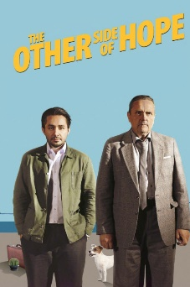 | The Other Side Of Hope – Sunday 26 November 2017  2017, Finland, 100mins Dir. Ali Kaurismaki  This tells the story of a young Syrian refugee, a stowaway, who winds up in Finland. The bizarre cast of characters he encounters there as well as his efforts to deal with a bewildering bureaucracy, provide the film with both its moments of hilarity as well as great sadness. It is impossible not to feel sympathy for the young man as his story unfolds and he attempts to negotiate his way through this minefield.
Members Choice – Sunday 17 December 2017

The members get to choose the film this month.
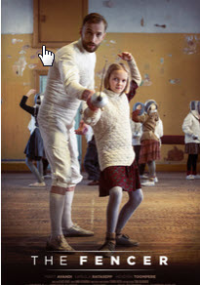 | The Fencer – Sunday 28 January 2018  2015, Estonia, 99mins Dir. Klaus Haro  Fleeing from the Russian secret police because of his controversial past, a young Estonian fencer named Endel is forced to return to his homeland, where he begins to train a group of young children in the art of fencing. The past however catches up with him and Endel has to choose between letting his students down or putting his life in danger. The movie is partially based on the real life story of an Estonian fencer Endel Nelis.
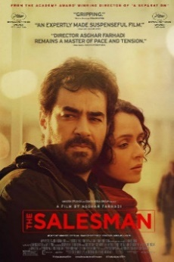 | The Salesman – Sunday 25 February 2018  2017, Iran, 125mins Dir. Asghar Farhadi  After their old flat becomes damaged, Emad and Rana, a young couple living in Tehran, are forced to move into a new apartment. Soon after relocating, a sudden eruption of violence linked to the previous tenant dramatically changes their lives, creating a simmering tension between husband and wife.
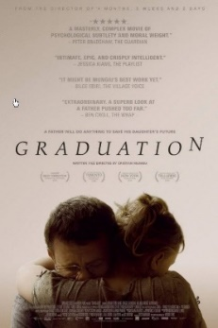 | Graduation – Sunday 25 March 2018  2017, Romania, 127mins Dir. Cristian Mungiu  Romanian Palme d’Or winner Cristian Mungiu’s latest film follows a doctor’s attempts to help his daughter pass a life-changing school exam with superbly subtle observation. It is a masterly, complex movie of psychological subtlety and moral weight about the complicated moral choices people make as they claw their way up.
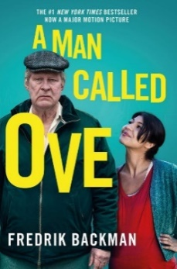 | A Man Called Ove – Sunday 15 April 2018  2017, Sweden, 116mins Dir Hannes Holm  Described by The Guardian as “a black comedy with a big heart” this is a moving and funny tale of a suicidal Swedish mechanic who is helped by his pregnant Persian neighbour. Rolf Lassgard’s fine, flinty performance of Ove reminds us of the importance of community and sharing without succumbing to sentimentality.

