Corbridge Film Nights 2016 -2017
Now in its seventh season, Corbridge Film Nights opens on Sunday 11 Sept with the film ‘The Second Mother’. A Welcome Evening is planned for this first meeting with pre-film complimentary drinks and nibbles.

- Diverse, critically-acclaimed films from all over the world.
- Corbridge Parish Hall, Sunday evenings.
- Doors open 7.00pm. Film starts 7.30pm. Finish ~ 9:30pm.
- You are welcome to bring your own refreshments.

The season of 9 films costs only £35 or pay on the door (£5)

For an application form contact :

John Wills, email: johnwills118@btinternet.com, tel: 01434 633995
Tom Southren, email: tom.southren@btinternet.com,tel: 01434 634909

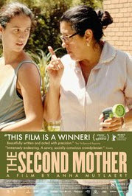 | The Second Mother – 11 September 2016  2015, Brazil, 112mins Dir. Anna Muylaert.  When the estranged daughter of a hard-working “live-in” housekeeper suddenly appears, the unspoken class barriers that exist within the house are thrown into disarray. Val has been working as a nanny for the Fabinho family for the past 13 years. She has to live with the guilt of having left daughter Jessica to be raised by relatives. However, when Jessica arrives in São Paulo, everyone is affected.
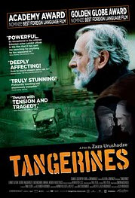 | Tangerines – Sunday 2 October 2016  2015, Russia, 87mins Dir. Zaza Urushadze  Set in 1992, during the conflict between Georgia and Abkhazian separatists in the wake of the Soviet Union's dissolution, this compassionate tale focuses on two Estonian immigrant farmers who decide to remain in Georgia long enough to harvest their tangerine crop. When the war comes to their doorsteps, Ivo takes in two wounded soldiers from opposite sides. Set against a beautiful landscape defiled by war, this poetic film makes an eloquent statement for peace.
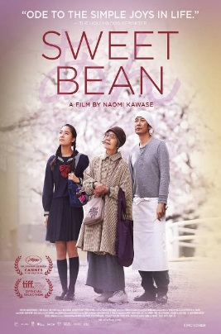 | Sweet Bean – Sunday 23 October 2016  2016, Japan, 113mins Dir. Naomi Kawase  A subtle study of the relationship between a lonely Japanese baker and a 76-year-old woman whom he hires to be his new assistant. He soon learns that she has a wonderful recipe for sweet red bean paste -- which she claims comes from her communion with nature. However, their partnership is threatened when it's revealed that the elderly woman is suffering from a severe illness. Beautifully photographed with dignified, understated performances.
Members Choice – Sunday 20 November 2016

You choose it, we show it !
Marguerite – Sunday 18 December 2016
2015, France, 129mins Dir. Xavier Giannoli

In 1920’s Paris, Marguerite Dumont, a wealthy woman, is a lover of music and opera. She loves to sing for her friends, although she’s not a good singer. Her friends and her husband have kept her fantasy. The problems begin when she decides to perform in front of a real audience.

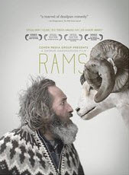 | Rams – Sunday 22 January 2017  2016, Iceland, 90mins Dir. Grimur Hakonarson  Winner of the Un Certain Regard prize at this year's Cannes Film Festival, this dark comedic drama, which is hilarious and heart-breaking, focuses on two Icelandic sheep farming brothers whose decades-long feud comes to a head when disaster strikes their flocks. Can these long-term enemies find common purpose when their ancestral stock and way of life are threatened?
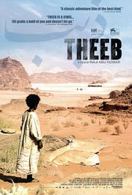 | Theeb – Sunday 19 February 2017  2014, United Arab Emirates, 100mins Dir. Naji Abu Nowar  In the Ottoman province of Hijaz during World War I, a young Bedouin boy experiences a greatly hastened coming-of-age as he embarks on a perilous desert journey to guide a British officer to his secret destination.
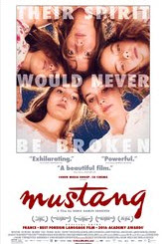 | Mustang – Sunday 19 March 2017  2015, Turkey, 97mins Dir. Deniz Gamze Erguven  Its summer. A village in northern Turkey. Five sisters come home from school, innocently playing with boys. Their “debauchery” causes a scandal. The family home slowly turns into a prison, classes on housework and cooking replace school. Marriages begin to be arranged. The five sisters fight back.
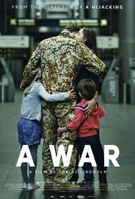 | A War – Sunday 23 April 2017  2015, Denmark, 115mins Dir Tobias Linholm  Denmark’s entry for this year’s best foreign language film Oscar is gripping and thought-provoking. During a routine mission, soldiers are caught in heavy crossfire and in order to save his men, Claus makes a decision that has grave consequences for him - and his family back home. Tense, intelligent, and refreshingly low-key, A War is part frontline thriller, part courtroom drama -- and eminently effective in both regards.

